
V7.3 Guide – Submitters

CONTENTS
I. INTRODUCTION 3
I.1. About ONEGATE 3
I.2. Summary of ONEGATE terms 3
II. Submission channels 4
II.1. UI submission channel (U2A) 4
II.2. Remote data transmission submission channel (A2A) 4
III. ONEGATE login page 5
IV. Page for requesting new access details 6
IV.1. Requesting access with a username and password 6
IV.2. Requesting access with a certificate 6
V. Changing your password 8
VI. General ergonomics 9
VII. Homepage 11
VII.1. Informative notes topic 11
VII.2. File upload topic 12
VII.3. Submission followup topic 13
VIII. Accessing your PROFILE 14
IX. REPORTS menu 15
IX.1. REPORTS menu – REPORT tab (Importing .csv files) 17
IX.2. REPORTS menu – IMPORT HISTORY tab 17
IX.3. REPORTS menu – REPORT tab – Accessing the form 18
IX.4. REPORTS menu – REPORT tab – Closing and sending the form 19
X. MONITORING menu – Submission followup 20
X.1. MONITORING menu – Submission followup – Page overview 20
X.2. MONITORING menu – Submission followup –Submission detail 21
XI. MANAGE menu – Document management 23
XII. Glossary 25
XIII. Appendices 25
XIII.1. Appendix 1: Procedure for exporting the electronic certificate in base 64 format (certificat.cer) 25
Projet test24/06/199801/06/199801/01/1998

INTRODUCTION
This guide, which is intended for submitters, presents the new version of the ONEGATE portal (V7.2).

About ONEGATE
The ONEGATE portal provides a “new organisation for exchanges via a window for uploading data and transferring data outwards” (in French, Organisation Nouvelle des Échanges via un Guichet d’Alimentation et de Transferts vers l’Extérieur).
ONEGATE allows the use of suitable formats and data collection methods for each declarer and for the information required while also reducing the overall workload, thereby benefiting the declarers as well as the Banque de France.

Summary of ONEGATE terms

Declarer/Reporting company: Company invited to send a set of predefined information.

Submitter: Stakeholder (Banking, Insurance or Corporate organisation) authorised to input or integrate data via the ONEGATE UI for itself or for others.

Submission: Expected data sent by a declarer to the Banque de France.

Submission channel: Transmission method:
- UI access (user-to-application or U2A) for making a submission or accessing information.
- Application-to-application (A2A) remote data transmission for making a submission without logging in to the UI.

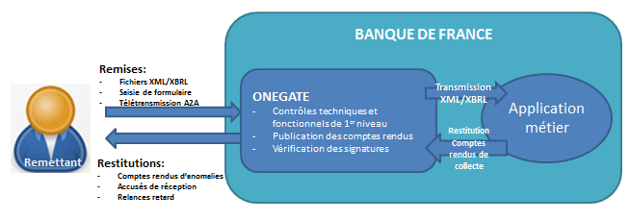

Submission channels

UI submission channel (U2A)
Two types of authentication are proposed, depending on the type of submissions involved:
- “Weak” access: username + password.
- “Strong” access: use of an authentication certificate.

Access URL:

Weak Production: | https://onegate.banque-france.fr/onegate
Strong Production: | https://onegate-strong.banque-france.fr/onegate
Weak Approval: | https://onegate-test.banque-france.fr/onegate/
Strong Approval: | https://onegate-strong-test.banque-france.fr/onegate/

To obtain a username and password or access via a certificate, you will need to request a user account via the ONEGATE login page (see §IV).
The documents needed to request a certificate or the renewal of your existing one are provided by your business mentor or via ONEGATE Support.

Remote data transmission submission channel (A2A)
Data can be transmitted remotely to ONEGATE using either one of the following transmission protocols:
- Via an EAI connection, requiring the creation of an EAI connection between the Banque de France system and the customer’s system;
- Via a web service, requiring a machine connection certificate and a call to a dedicated URL.

Details of each remote data transmission are available in French on the Banque de France website (https://www.banque-france.fr/statistiques/portail-onegate in the “Notice technique modalité de remise par télétransmission” (Technical procedure for making submissions via remote data transmission) section). For further information, please contact your business mentors or ONEGATE Support.

ONEGATE Support is available from 8 a.m. to 7 p.m. by phone at +33 (0)1 42 92 60 05 or by sending an email to Support-OneGate@banque-france.fr

ONEGATE login page

The login page of the ONEGATE application has been redesigned.

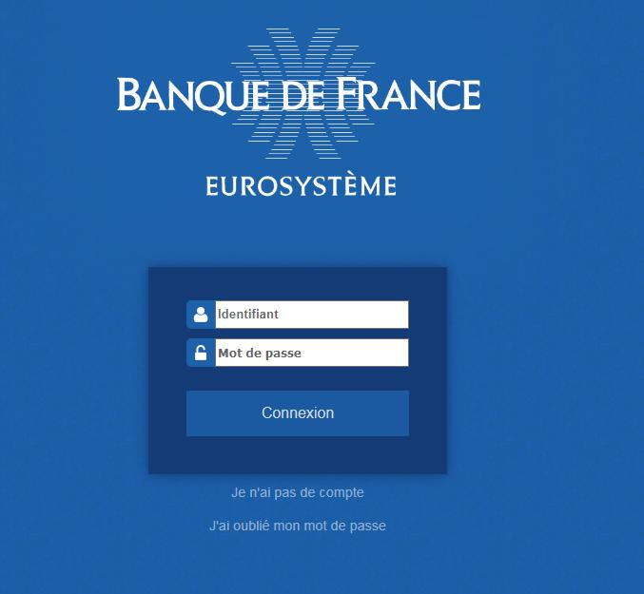
121
2121
3121
4121
1 | Username input field  Enter your email address.
2 | Password input field
3 | Access request link  This link is used to request the creation of a ONEGATE account (see §IV).
4 | Password reset link  This link can be used to reset your password (see §V).

Page for requesting new access details

Requesting access with a username and password
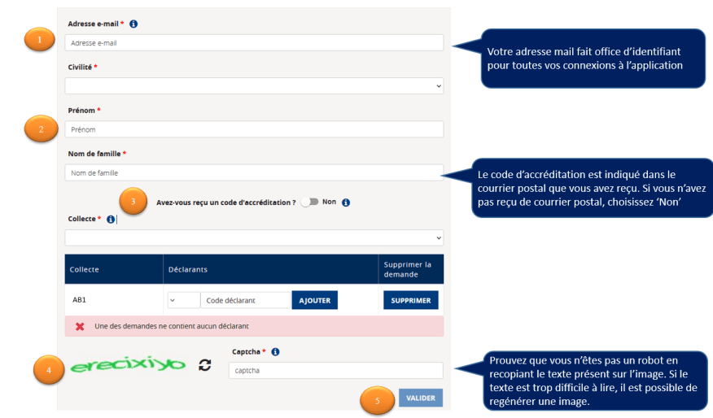

1 | Email address input field  This personal, business email address will be used as your unique username.  A generic email or shared mailbox cannot be used as a username.
2 | Identity input field  Title, first name and surname.
3 | Have you received an accreditation code?  If you select Yes you are asked to enter the code provided by your business mentor. Certain data can only be collected using a code  If you select No, you are asked to select the data collections and declarers for which you are requesting access.
4 | Captcha check  For security reasons, you must enter a security code (captcha).
5 | Confirmation button  After clicking the confirmation button, a delivery receipt email summarising your request will be sent to the valid email address you specified.

Requesting access with a certificate
Certain ONEGATE surveys (DATAGAPS – DATABRI) require you to request portal access with an authentication certificate (see § II.1.).

In this case, as the submitter, you will be asked to import your authentication certificate. This is a file in CER format encoded in base 64 (see Appendix for the certificate export procedure).
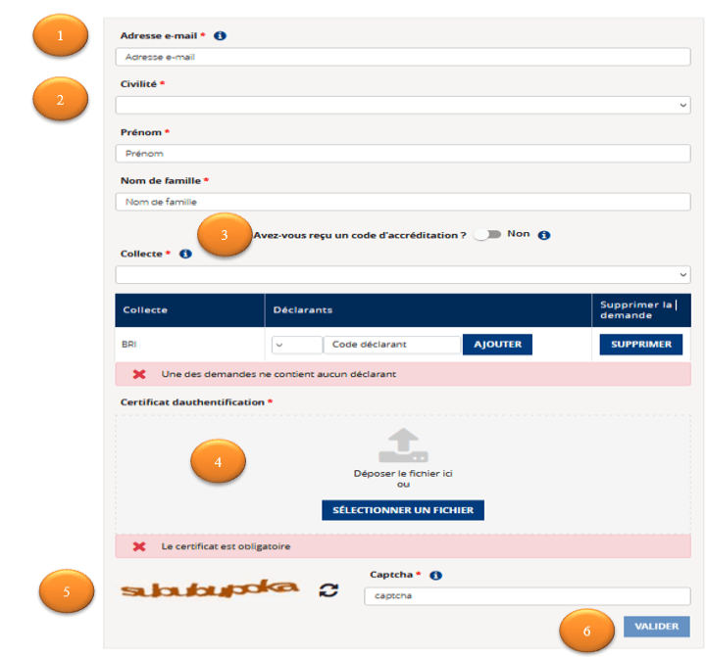

1 | Email address input field  This personal, business email address will be used as your unique username.  A generic email or shared mailbox cannot be used as a username.
2 | Identity input field  Title, first name and surname.
3 | Have you received an accreditation code?  If you select Yes you are asked to enter the code provided by your business mentor. Certain data can only be collected using a code  If you select No, you are asked to select the data collections and declarers for which you are requesting access.
4 | Certificate  Import the certificate already saved in CER format in base 64 (the procedure for exporting in base 64 can be found in the Appendix).
5 | Captcha check  For security reasons, you must enter a security code (captcha).
6 | Confirmation button  After clicking the confirmation button, a delivery receipt email summarising your request will be sent to the valid email address you specified.

If your request has been approved by a business manager:
- You receive an initial email containing a temporary password sent to the valid email address specified.
- You receive an approval conformation email for each Collection/Declarer pair.
If your request has been rejected by a business manager:
- You receive an email containing the reason for the request being rejected for the Collection/Declarer pair concerned.

Renewing your certificate
- Whenever you renew your certificate, you should send your new certificate to ONEGATE Support for your account to be updated with this new certificate.

Changing your password
Every 63 calendar days you will be asked to change your user password.
Depending on the sensitivity of the data collected, the passwords concerned may not expire.
If your password is due to expire soon, a warning message will be displayed when you log in.
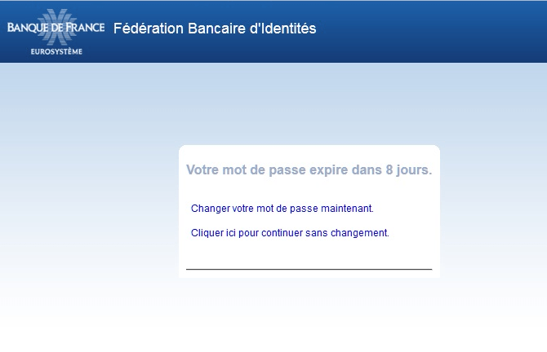

You can change your password at any time by clicking on the “J’ai oublié mon mot de passe” (I have forgotten my password) link on the login page. An email will then be sent to the email address that you specified when you requested access.

The link allowing you to enter your new password is valid for one hour, after which time a message saying that the link is no longer valid is displayed. If this happens, you must click the “J’ai oublié mon mot de passe” link again.

The rules for creating a new password are shown on the input screen.

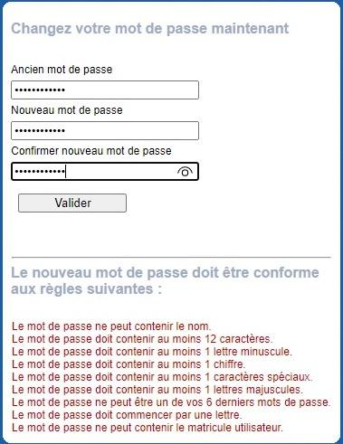

After your new password has been entered and validated, a confirmation message is displayed.
a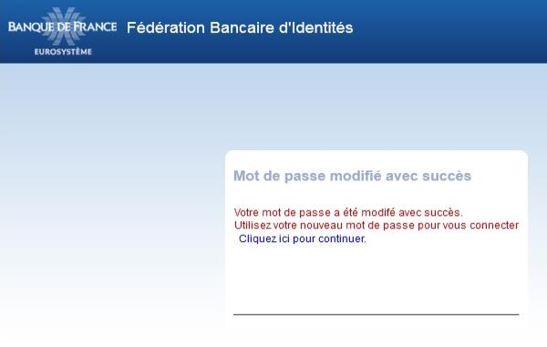

Clicking the link it contains sends you to the ONEGATE login page.

General ergonomics
The application’s general ergonomics have been improved to provide a better user experience.
- A breadcrumb trail has been added to enable users to go back to the Submission followup UI from the submission details page, keeping the same filters.
- A new PROFILE menu has been added to make it easier for users to access their data, contact details and requests for access rights extensions.

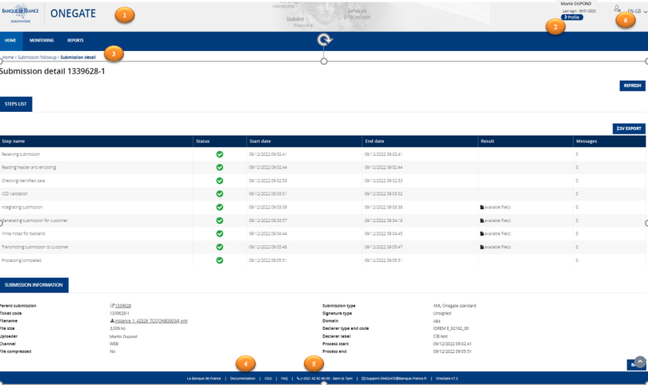

1 | Banque de France logo  Click the Banque de France logo in the top left-hand corner to go back to the homepage (see §VII).
2 | Accessing your profile  To access your profile, click the >Profile button in the top right-hand corner, above the main menu bar (see §VIII).
3 | Breadcrumb trail  This allows you to return to the homepage or the Submission followup UI from the submission details page, keeping the same filters.
4 | Documentation  Click Documentation to access the ONEGATE portal and view the different documents relating to the application, including the full user guide and release note on the current version.
5 | Support contact details  The contact details of ONEGATE Support are displayed at the bottom of the page.
6 | Logout  Click the cross in the top right-hand corner to log out.

Homepage

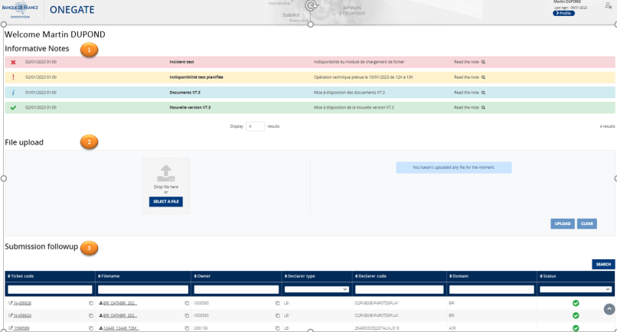
321221
1
21221

1 | Informative notes  The Informative Notes topic can be found in the top section of the homepage, covering the entire width of the page. It is described in section VII.1.
2 | File upload  The File upload topic covers the middle section of the homepage. It is described in section VII.2.
3 | Submission followup  The Submission followup topic is located in the bottom part of the homepage and shows all recent submissions. It is described in section VII.3.

Informative notes topic

These notes provide information on application events or events specifically affecting your submissions.
They are colour coded as follows:

- Red for an unplanned unavailability
- Orange for a planned unavailability
- Blue for general information notes
- Green to show that a new version is available

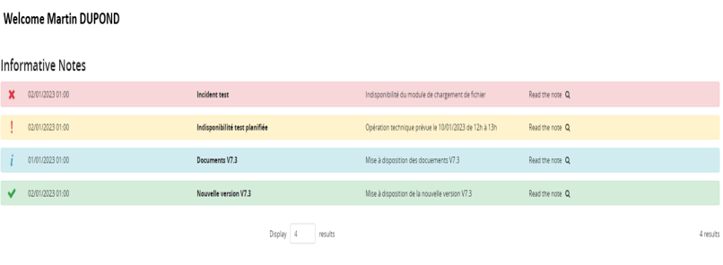
To view the contents of an informative note, click the magnifying glass on the right-hand side of the chosen line.
For example, if you click on the magnifying glass in the Incident test line, a pop-up box will appear showing you details of the incident.

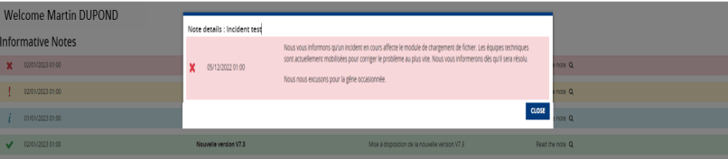

File upload topic
The File upload topic displayed on the homepage can be used to upload signed or unsigned .xml/.xbrl files (compressed files in .ZIP format are allowed).
You can upload files using one of the following methods:
- Select, drag and drop one or more files into the topic.
- Use the Select a File button to retrieve a file stored on the workstation or in a shared folder.
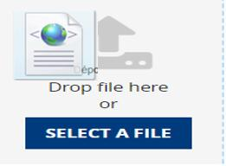
Once the file(s) has/have been placed in the box, the Upload button is enabled.

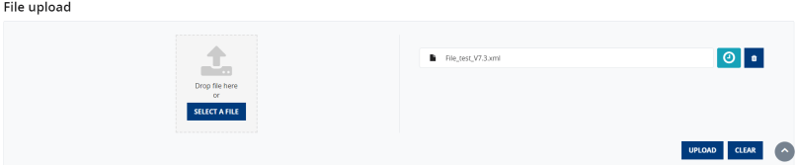

When you click this button, the file(s) enter(s) the integration process and a ticket number is displayed. Clicking on this ticket number will take you to the Submission detail page

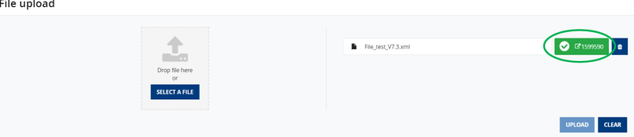

Submission followup topic
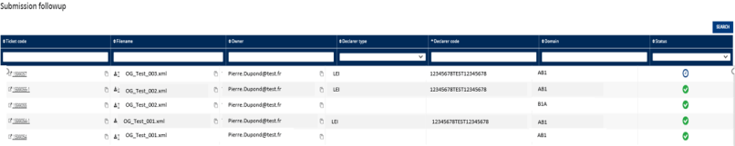

The Submission followup topic provides a summary of the status of the five most recent submissions.
- You can select a submission in order to consult its details.
- To consult the details of a submission, click the related line (see §X.2).

Accessing your PROFILE
You can access your profile by clicking on the >Profile button in the top right-hand corner of the screen.

-+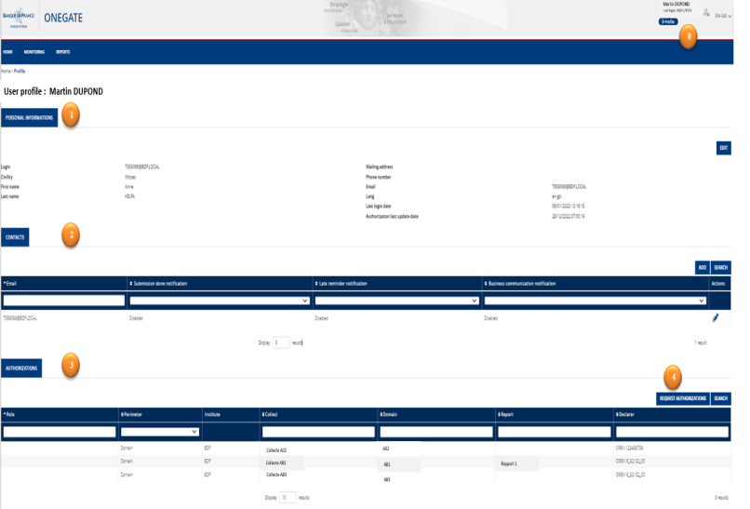

0 | Accessing your PROFILE  This new link in the general menu allows you to access information linked to your submitter profile and request extensions to your access rights.
1 | Personal information  You can change your personal information (title, first name, surname, postal address, telephone number and email address). If you wish to change your username, you can also update your contact email address at the same time by clicking on “Mettre à jour l’email de contact” (Update email address).
2 | Contacts  The Contacts box is provided to enable you to manage the notification email recipients.  You can configure this box as required.  You can assign one or more notification types to each email.  Three notification types are available:  - Submission done notification: receive messages related to a submission and file processing  - Late reminder notification: receive messages related to late reminders  - Business communication notification: receive messages relating to business data collection feedback  Example: The submitter has chosen to tick the “Submission done notification” and “Late reminder notification” boxes for the email address “Martin.Smith@XXX.co.uk”. Martin Smith will be notified of all submissions by the submitter and all messages sent by the collection manager.  Note: for A2A MFT or A2A Web service submitters, it is possible to specify recipients for e-mail notifications. To do this, you will need to submit a request to the support service, indicating the A2A account to which you want the contact addresses to be attached.
3 | Authorizations  This box summarises all validated accreditations (Declarers and Reports) and related Roles.
4 | Request authorizations  This box is used to request rights for a new Declarer/Domain pair. It functions in a similar way to the access request (see §IV).

REPORTS menu
The online input fields have been modified to make it easier to select search filters.
Once you click on the REPORTS tab, you can search for report(s) using two different criteria: by domain or by declarer.

- Search by domain/report:

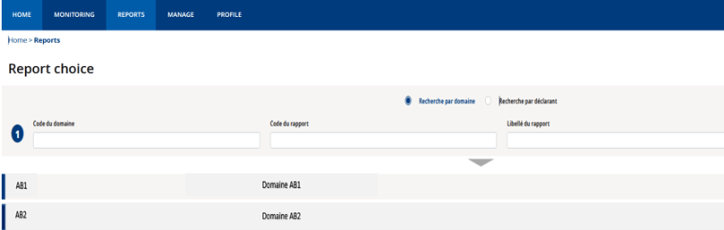

The filters relating to domains (domain code, report code, report name) are displayed, along with the list of domains.

- Search by declarer:

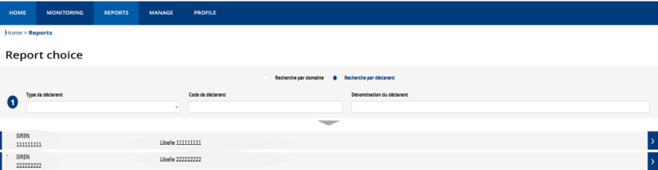

The filters relating to declarers (declarer type, declarer code, declarer name) are displayed, along with the list of declarers.

- Once you have selected the domain and declarer, the form(s) relating to the most recent report period will open, allowing you to modify one of the three following filter criteria:
  - The domain
  - The declarer
  - The period
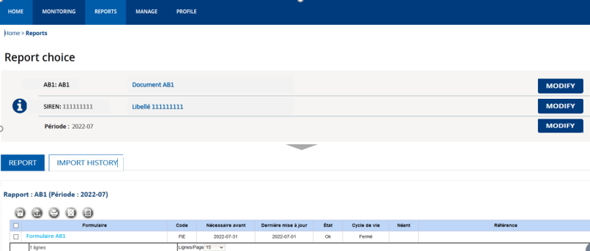

- To access the list of periods, click Modify opposite the Period field.

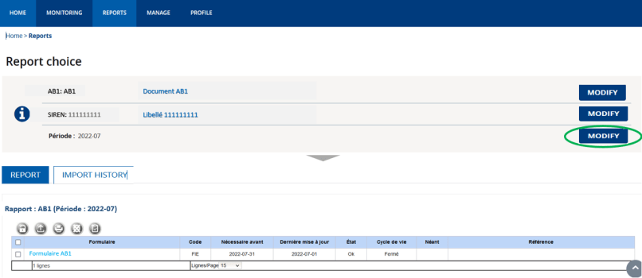

- In the table showing all available periods (in descending order), choose the desired period by clicking on the button in the Selection column in the corresponding line.

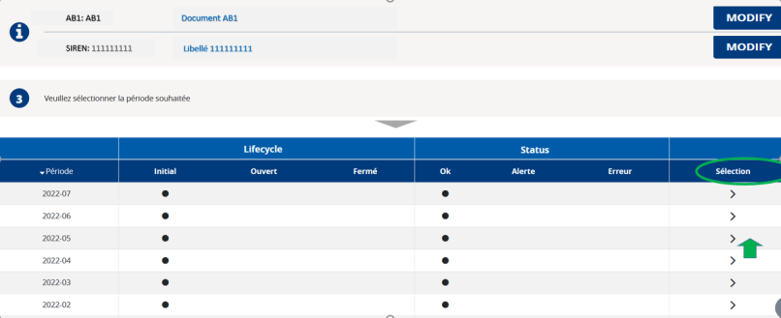

The period is defined by its lifecycle: Initial, Open, Closed; and by its status: OK, Alert or Error.

REPORTS menu – REPORT tab (Importing .csv files)
You can only perform this action for certain surveys.

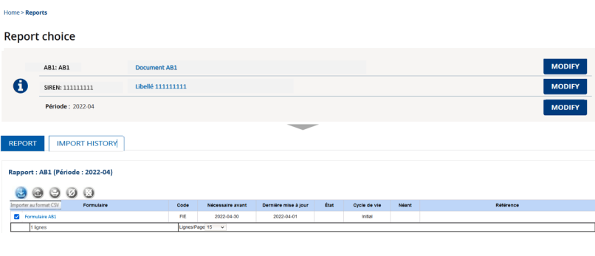
Tick the desired form and then click “Importer au format CSV” (Import CSV).

Depending on the desired integration mode, you can select the type "Ajout" (Add) or "Remplace” (Replace).

The loaded CSV file must be encoded in “UTF-8”.

At the "Encodage” (Encoding) line, select the "UTF-8" encoding type.

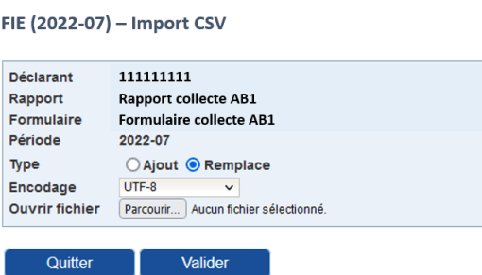
The page displayed allows you to import the file in CSV format.

REPORTS menu – IMPORT HISTORY tab
The online input fields have been supplemented by a new tab that lists the .CSV files imported: IMPORT HISTORY.

- When you fill in an online input form for a CSV import, you can view the list of imported .CSV files by clicking on the IMPORT HISTORY tab.
- You can download the error report in .XML format (Feedback column) or view it in the UI ( button in the Actions column).

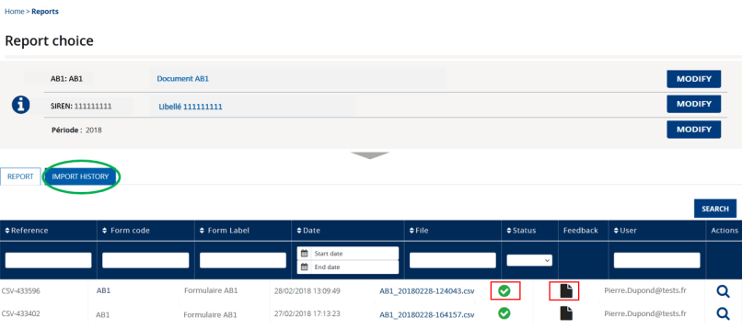

To download the contents of the report in. XML format, click the icon in the Feedback column.

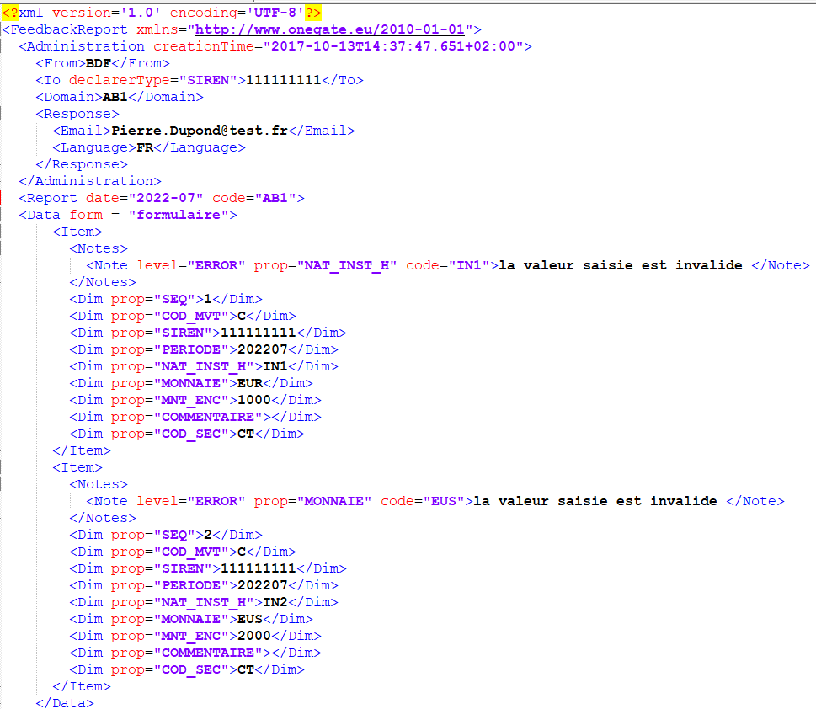

REPORTS menu – REPORT tab – Accessing the form
Click the “Formulaire” (Form) link displayed to access the form.
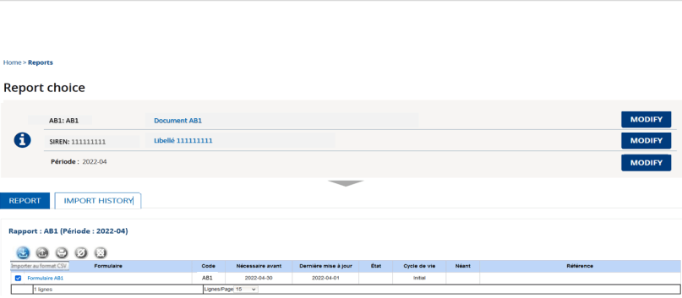

REPORTS menu – REPORT tab – Closing and sending the form
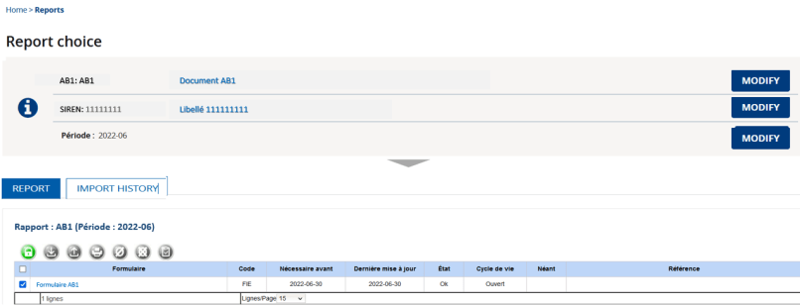

Click the checkbox in the first column and then click the padlock icon (green button) to close and send the form.

MONITORING menu – Submission followup

MONITORING menu – Submission followup – Page overview
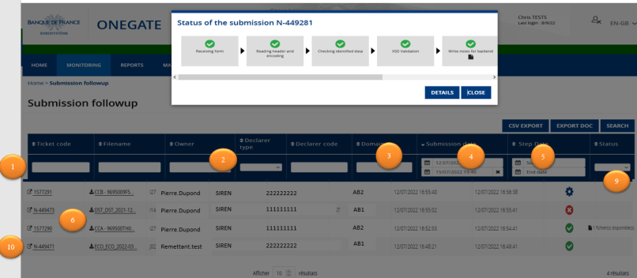

1 | Search input field  You can perform a search by entering the desired term in the column header.
2 | Declarer type drop-down list  You can perform a search by selecting the desired declarer type.
3 | Submission date selection box  You can perform a search by selecting the desired date in the column header.
4 | Step date selection box  You can perform a search by selecting the desired step date.
5 | Status selection box  You can perform a search by selecting the desired file processing status.
6 | Ticket code box with the prefix N- for online entries  Submissions made online under the Report tab now appear on the submission followup page (MONITORING menu/Submission followup tab). Online file submissions have the pre-fix N- at the start of their ticket code.
7 | CSV export  You can export the submission followup table generated using your chosen filters in .csv format by clicking on the CSV EXPORT button.  You will be asked to select the number of lines to be exported or to export the entire table. Once you have made your choice, click the Download button and wait while the file is generated.  Depending on your browser, a window may be displayed asking whether you want to open or save the file.
8 | Export doc – Document search  The EXPORT DOC button allows you to search for one or more documents in a submission using search criteria.  The documents found can then be downloaded.  This function is only available for the domains configured to receive documents.
9 | Document column  One or more “appended” documents may be attached to and available in a submission, irrespective of the submission’s status.  You can filter the documents by status (Present/Absent).  Click the icon to download the documents.  The icon is followed by a number indicating the number of documents available.  This function is only available for the domains configured to receive documents.
10 | File progress step  Clicking on a line will display the different steps in the file processing. This option is available for all types of submissions:  - XML submissions  - XBR submissions  - Online submissions  For some steps, a link will appear allowing you to open or save the corresponding feedback report. This link can also be found in the Result column in the submission details.  Click the DETAILS button to view the details of the submission.

MONITORING menu – Submission followup –Submission detail
The submission details page displays a set of technical and application information on the selected submission. For certain domains, business reports are available in the Monitoring menu, under Documents (CF §XI) after the file has been uploaded and will inform you of any anomalies contained in your submission.
To display a submission’s details page, click its ticket number in the submission followup page, or click its ticket number on the homepage displayed following a U2A file upload.

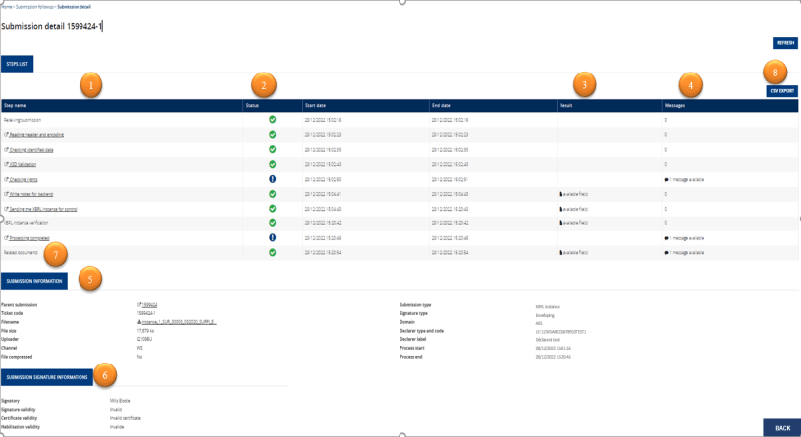

Example of the details of a submission signed in standard ONEGATE format:

1 | File progress step  Displays the details of each submission step.
2 | Status column  This column displays the results of the step processing. There are three possible statuses:  - Successful  - Warning  - Failure
3 | Result column  For certain steps, you can download the related processing feedback .
4 | Messages column  Displays the number of messages present for each line. If the number is different from 0 you can click the icon in front of the number to view the messages for this step.
5 | Submission information box  - Displays a summary of the submission file information.  - For submissions with several sections (XBRL, Protide or multi-report submissions), each section has a ticket number.  - Click the link in the “Parent submission” field to go back to the details of the parent submission.  - Click the link in the “Report and period” field to go back to the online entry page for the report and period concerned.
5 | Submission signature information box  - For signed submissions, the following information is shown in the box:  - Signatory  - Validity of the signature  - Validity of the certificate  - Validity of the authorisation
7 | Related document(s) step  This step is only available for the domains configured to receive documents.  One or more “related” documents may be attached to and available in a submission, irrespective of the submission’s status.  The documents can be downloaded:  - All at once as a .zip file by clicking on the file icon in the Result column  - One by one by clicking on the link in the Messages column, as shown in the screen shot below.  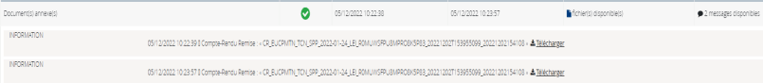
8 | Refresh button  Click the Refresh button to refresh the list.

MONITORING menu – Documents
The ONEGATE messaging system has been replaced by a document management system listing all documents received by domain and by declarer.
Access to this information is governed by your user rights for the Declarer/Domain pairs concerned.
All documents that previously appeared in the Manage menu under Document Management are now displayed in the Monitoring menu, under Documents.

For the specific purposes of the SURFI and OFIS-OT collections available for the first half of 2020 and relating to the personalisation of emails, the back end sends emails to submitters via ONEGATE. These emails can be viewed on this page in document form.

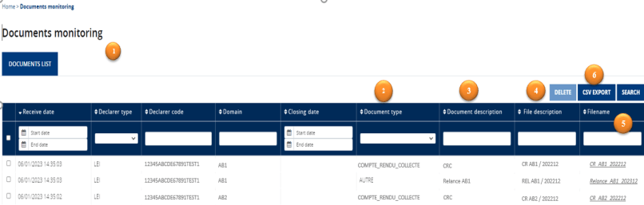

1 | Table of documents  The table contains the following nine columns:  - Receive date: date of receipt of the document, which can be selected in the header  - Declarer type: drop-down list  - Declarer code: enter in the column header  - Domain: enter in the column header  - Closing date: date indicated in the uploaded file if it has been entered; select in the column header  - Document type: drop-down list  - Document description: enter in the column header  - File description: enter in the column header  - Filename: enter in the column header  All the columns can be sorted and filtered.
2 | Document type  The type is defined by the business line. It can be CRC, Late reminder, Other, etc. It shows what type of action has been carried out to update the submission.
3 | Document description  Additional, non-mandatory field describing the document.
4 | File description  This field may contain information on the submission linked to the uploaded document (e.g. ticket number) or other information on the contents of the uploaded file.
5 | Filename  Name of the attached file.  Click on the link to download the document.  For the personalised email, the body of the sent email is the contents of the file if they are in html format.
6 | CSV Export  Click on this button to export one or more lines in the table.  The size of each document is indicated in a column in the export results.

Glossary
Acronyms | Definitions
A2A | Application to Application
U2A | User to Application
UI | User Interface
URL | Uniform Resource Locator
Captcha code | Code used to distinguish between humans and computers

Appendices

Appendix 1: Procedure for exporting the electronic certificate in base 64 format (certificat.cer)
Exporting the electronic certificate in base 64 format (certificat.cer)

- Run the certification manager by typing certmgr.msc as follows in the Start menu (in the “Search programs and files” box), and then press the Enter key.

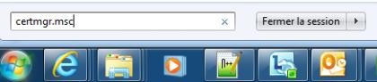

Alternatively, press the Windows+R keys: 

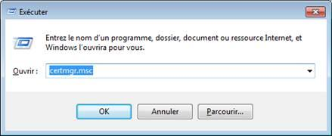

- Go to “Personnel/Certificats” (Personal/Certificates) and check that your electronic certificate is present.

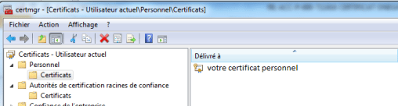

- Extract your public key as follows:
  - Right-click your personal certificate. In the contextual menu, select “Toutes les taches” (All tasks) then “Exporter…” (Export…).

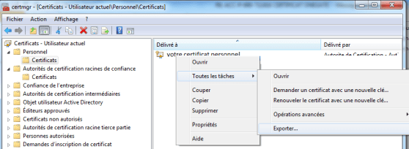

  - Click “Suivant” (Next).

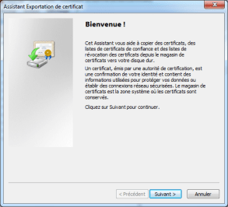

  - Select the “Non, ne pas exporter la clé privée” (No, do not export the private key) option, and then click “Suivant” (Next).
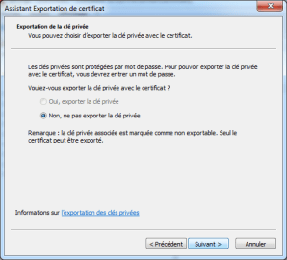

  - Select the “X.509 encodé en base 64 (.cer)” (X.509 encoded in base 64 (.cer)) format option, and then click “Suivant” (Next).

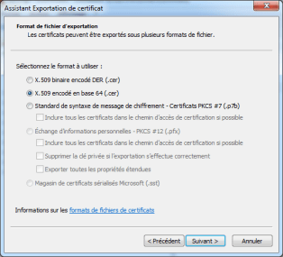

  - Fill in the name of the file – for example, Public_Key_Surname_Forename – and then click “Suivant” (Next). Check the location of the file by clicking “Parcourir…” (Browse…) so that you can find it again.

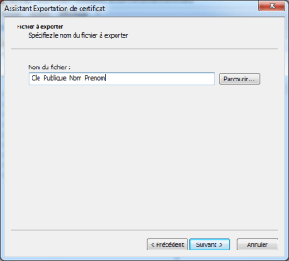

  - Click “Terminer” (Finish).

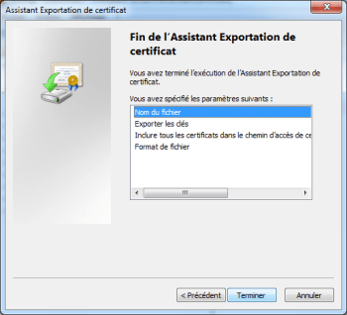

- The Public_Key_Surname_Forename.cer file is created in base 64 format.

